**NEXTION DISPLAY:-**

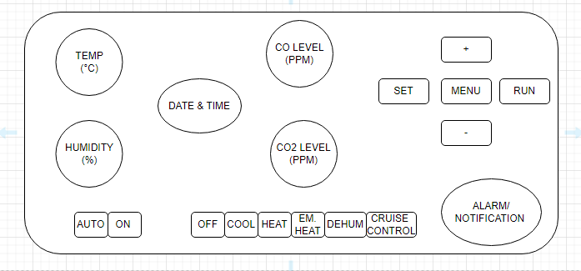

* There is two mode for FAN: - 1. AUTO

2. OFF

* Six mode of SYSTEM: - 1. OFF

2. COOLING

3. HEATING

4. EMERGENCY HEAT

5. DEHUMIDIFY

6. CRUISE CONTROL

**OPERATIONS:-**

